Create a chatbot in python

Phase-3

submission

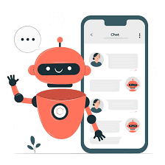

**Team member name** : Dinesh J

**NM id** : au410121104013

**Dept**  : Cse-III year

**College name** : Adhi college of engineering and

technology

**Domain**  : AI101(IBM-Artificial group-1)

**Team name** : The enthusiastic coders

**Introduction:**

In the age of artificial intelligence and natural language processing, chatbots have become increasingly prevalent, offering interactive and engaging user experiences. This project aims to create a sophisticated chatbot that leverages the power of GPT-3, a state-of-the-art language model developed by OpenAI. The chatbot will not only provide answers to user queries but also engage in meaningful and context-aware conversations.

The project begins with setting up the environment by installing essential libraries like "transformers" for GPT-3 integration and "Flask" for web app development. We'll load and preprocess the dataset, configure the GPT-3 API, and develop a Flask web application to serve as the user interface. Users will be able to interact with the chatbot through this web app, making it accessible and user-friendly.

**Dataset loading and creating a dataframe:**

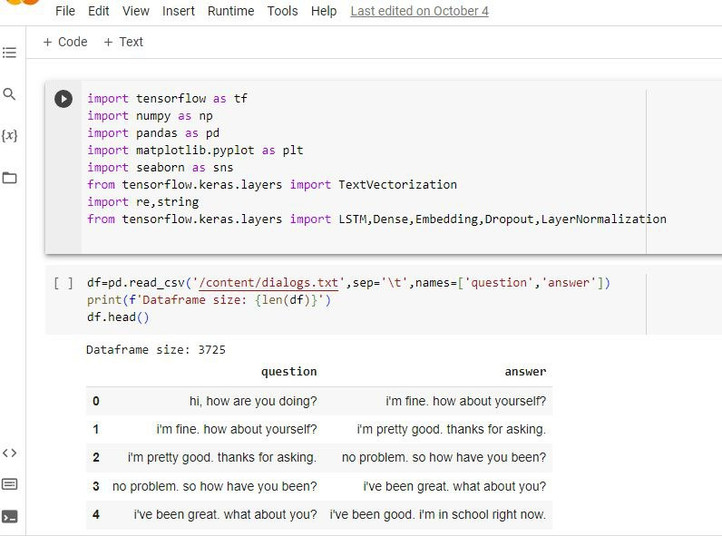

**Cleaning the dataset:**

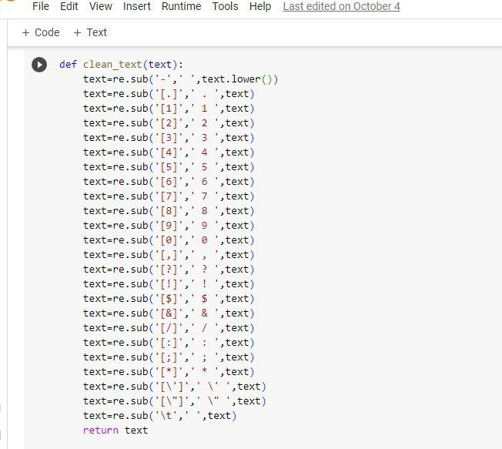

**Encoding and decoding:**

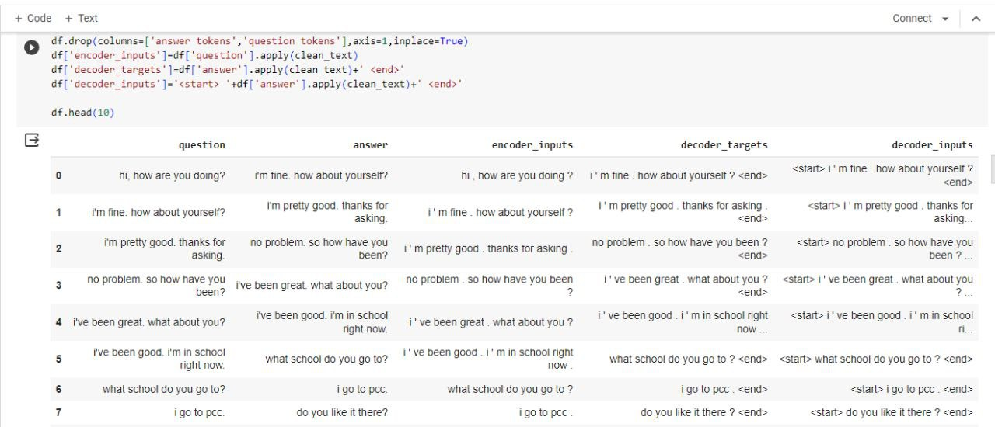

**After preprocessing:**

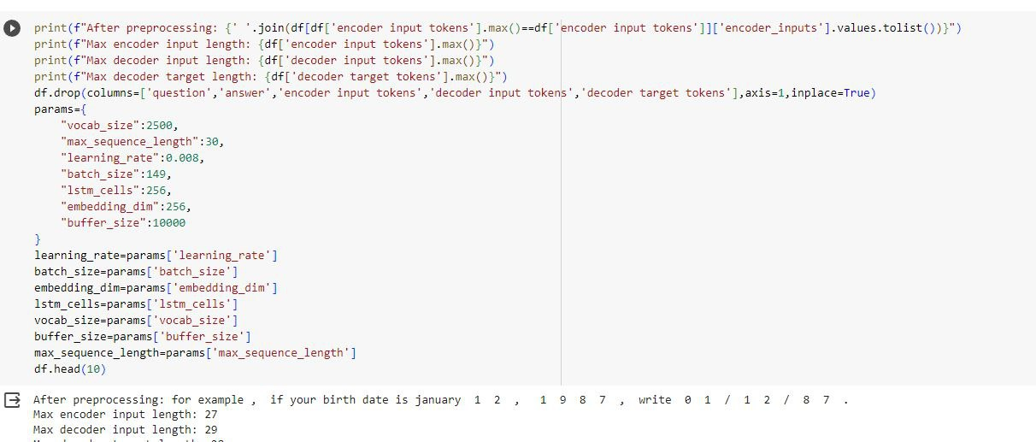

**Install transformers:**

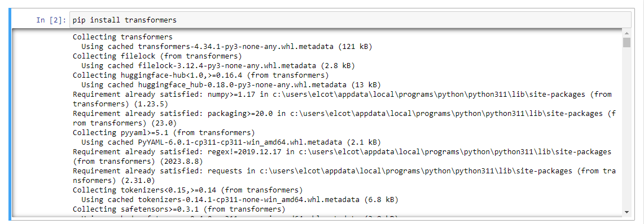

**Install flask:**

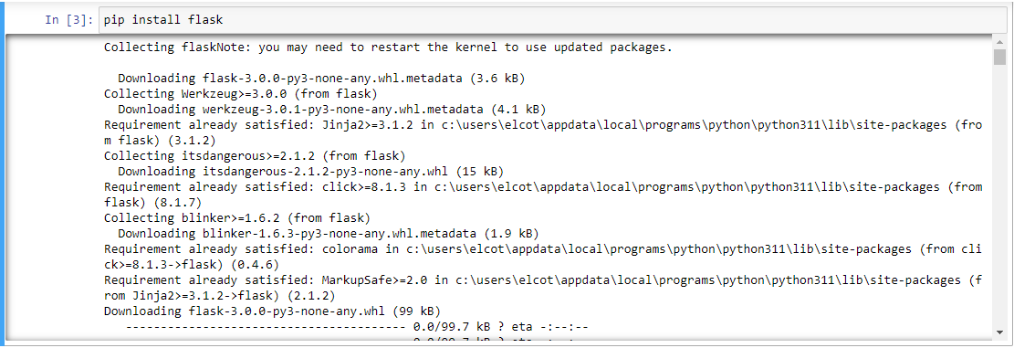

**Conclusion:**

In conclusion, this chatbot project demonstrates the potential of combining cutting-edge language models with web development to create an interactive and intelligent conversational agent. By successfully implementing the environment setup, dataset preprocessing, GPT-3 integration, and user interactions, we've laid the groundwork for a powerful chatbot. Users can now engage in dynamic and context-aware conversations, making this project a valuable addition to the realm of AI-driven applications. As AI technologies continue to advance, the possibilities for chatbots and their real-world applications are limitless, and this project serves as a starting point for exploring those horizons.

**Thanking you…….**